

BETHUNE-COOKMAN UNIVERSITY
STUDENT SUPPORT SERVICE INSTRUCTIONS & GUIDELINES

ANNUAL PLANNING, BUDGETING &

ASSESSMENT REPORT

Office of Assessment 9/9/2024

Bethune-Cookman University

Contents
Introduction 2
Annual Planning, Budgeting and Assessment Cycle 2
Instructions for Filling out the Annual Planning, Budgeting and Assessment Report 3
Description of the Administrative/ Academic and Student Support Unit 3
Mission 3
How to Write a Mission Statement 3
Components of a Program Mission Statement 3
Structure of a Program Mission Statement 4
Mission Statement Example 4
Outcomes 4
Characteristics of Outcomes: SMART 5
Resources Used 6
Support Specifics 6
Teaching 6
Research 6
Community and Public Service 6
Analysis Grid 7
Assessment Plan (Methods and Procedures) 8
Analysis and Evaluation 9
Action Plan 9
Rubric for Assessing the Annual Assessment Report 9
“Accrediting agencies – both at the institutional level and the programmatic level – are now operating in a ‘culture of evidence’ that requires institutions to qualitatively and quantitatively demonstrate that they are meeting student learning goals and effectively marshalling human and fiscal resources
toward that end.”
Michael Middaugh
Author of Planning and Assessment in Higher Education

Introduction
Assessment involves both academic and non-academic areas of B-CU. Assessment is the ongoing process of:
- establishing clear, measurable, expected outcomes;
- implementing programs and practices designed to achieve predetermined outcomes;
- systematically collecting, summarizing, and evaluating evidence to determine how well programs and practices are working at meeting their expected outcomes;
- and using the evidence to understand and improve institutional effectiveness by ensuring an efficient use of University resources.

Assessment is an integral part of the annual planning activities at Bethune-Cookman University, as it determines whether or not the objectives of education are being met. The main goals in the assessment of educational and administrative support services are to:
- document what support of learning is taking place and,
- use the results of assessment activities to improve the student learning environment.

Annual Planning, Budgeting and Assessment Cycle
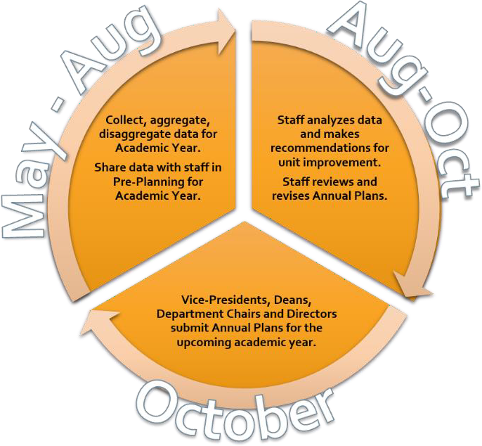

Instructions for Filling out the Annual Planning, Budgeting and Assessment Report

Description of the Administrative/ Academic and Student Support Unit
In this section, provide a brief overview of your unit. Be sure to describe the functions, structure, and purpose of your educational and administrative support services.
Example
Student Health Services at Bethune-Cookman University is here to help build a better and healthier future for all of our students by providing exceptional care, advocacy and support. Our staff is committed to our students’ personal well-being and the prevention of illness and diseases. Furthermore, we provide services that support their ability to remain physically, mentally, emotionally, spiritually, and socially healthy.

Mission
Please include your unit’s mission. Remember that the mission of the unit must be aligned with the Mission of the University and demonstrate that it supports the Mission of the University.
The current mission statement of the University is as follows:
The mission of Bethune-Cookman University is to educate a diverse community of learners to become responsible, productive citizens and solution seekers through the promotion of faith, scholarship, creative endeavors, leadership and service.
How to Write a Mission Statement
Source: http://assessment.uconn.edu/docs/HowToWriteMission.pdf

The mission statement is a concise statement of the general values and principles which guide the curriculum. A program mission statement:
- is a broad statement of what the program or unit is, what it does (action), and who is the target
- is a clear description of the purpose of the program or unit and the learning environment?
- reflects how the program contributes to the education and careers of students graduating from the program or how the unit supports it customers
- is aligned with department, school and University missions
- should be distinctive for the program or unit

Components of a Program Mission Statement
- Primary functions or activities of the program or area – What are the most important functions, operations, and/or offerings of the program or area?

- Purpose of the program or area – What are the primary reasons why you perform your major activities or operations?
- Stakeholders – Who are the groups or individuals that participate in the educational or administrative support services and those who benefit from your area?

Structure of a Program Mission Statement
“The mission of (name of your program or area) is to (your primary purpose) by providing (your primary functions or activities) to (your stakeholders). (Add additional clarifying statements as necessary).

Note: The order of the elements in the mission statement may vary from the above structure.

Mission Statement Example
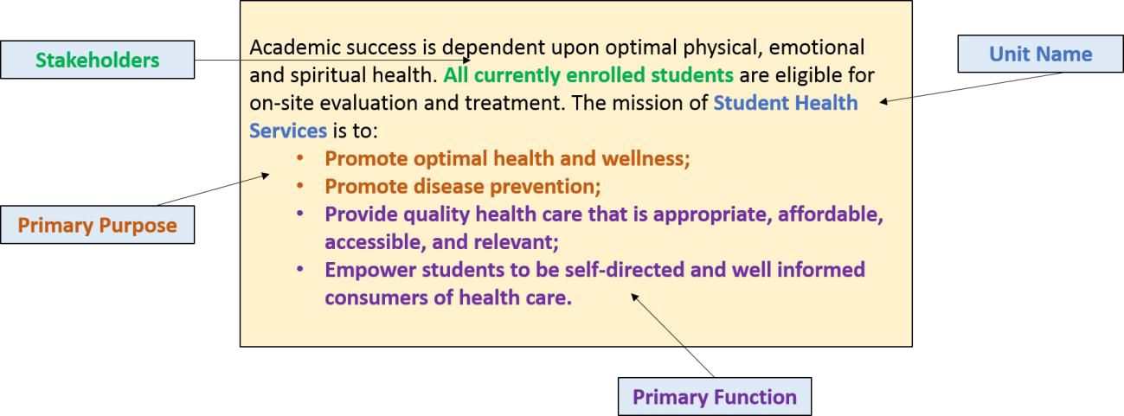

Outcomes
List the expected outcomes for your area (administrative or academic and student support services) as aligned with Bethune-Cookman University’s Strategic Goals. The professional staff in each unit are to work together to establish a limited number of overarching outcomes for the unit as a whole. Be sure to use a numbered list.
1.
2.
3.
4.
Administrative or academic and student support areas typically have outcomes that focus on the critical functions, services, and processes that impact the student learning environment with an emphasis on

efficiency, quality, or satisfaction. Some outcomes may be more basic such as; establishing something initially, gathering baseline data, or reviewing a process.

Characteristics of Outcomes: SMART
- Specific - The outcome is clear among all choices and not bundled with multiple outcomes
- Measurable – The outcome contains quantifiable terms. In many cases, examination of records, logs of activities, and supporting documentation may play a large role in the measurement of your outcomes.
- Attainable – The outcome is reasonable give the area's resources and influence
- Relevant - The outcome must be relevant to the area's mission, responsibilities, and all people affiliated with the area
- Time-bound - The period of time for accomplishing goal is reasonable

In addition,
- Outcome statements should be developed, agreed upon, and supported by members of the unit.
- Outcome statements do not include ‘understand’ or ‘know’ because the words are not, by themselves, measurable.
- Outcome statements should be understood by anyone.

Types of Assessments for Administrative Support Services /Academic and Student Support Services

Satisfaction
  - General (institutional)
  - Specific (satisfaction with particular area)

Direct Measures
  - Volume of Activity (# of persons served)
  - Level of Efficiency (average response time)
  - Quality average (# of errors)

External Validation
  - Audits (financial, IT)
  - Public Health Inspector
  - Fire Marshall

Example: Registrar
Outcome 1: The Office of the registrar will process transcript requests within two business days.
Benchmark: 90% of transcript requests will be processed within 2 business days.
Measure/Tool: Log of transcript requests (monthly)

Outcome 2: The Office of the registrar will be in compliance with FERPA regulations. Benchmark: 100% of employees will answer 90% of the questions on a FERPA questionnaire correctly.
Measure/Tool: Survey

Resources Used
Briefly describe resources, including personnel, used to accomplish the outcomes. It may be beneficial to review expenditures during the fiscal year (July 1 – June 30) to categorize where resources were allocated within your unit.
Areas to address in your brief description:
- Number of personnel utilized to accomplish each outcome
- Categories of expenditures that consumed a substantial portion of your budget (with computations and details when available)
- Physical space/facilities utilized

Support Specifics
Under the headings below (Teaching, Research, and Community and Public Service) add descriptions to explain the specific ways in which your unit supports the University’s activities.

Teaching
Briefly describe how your unit supports the teaching and learning enterprise.

Research
Briefly explain how your unit engages in activities related to research and how your unit supports research at the University.

Community and Public Service
Briefly state any unit goals related to community and public service and how your unit supports service at the University.

Analysis Grid
Column 1 (Outcomes): When completing the Analysis Grid, list the identical outcomes that you listed earlier in the report in the first column. You may need to right mouse click on the template once your cursor is in a row and then select “Insert → Insert Rows Below” to add additional rows to the grid based on the number of outcomes in your unit.
Note from the Assessment Rubric: The outcome statement clearly focuses on the critical functions, services, and processes that impact the student learning environment with an emphasis on efficiency and quality. The outcome uses action verbs, is relevant to the area and attainable in the time-frame (usually one year).
Column 2 (ELOA): Next, list the expected levels of achievement (ELOA) for each outcome. You can have multiple measures for each outcome, so you should list each ELOA, making sure that you keep the ELOA parallel with the measure(s)/tool(s) used as listed in the next column.
Note from the Assessment Rubric: The expected levels of achievement should be appropriate and aligned with best practices and other institutions. For multiple measures on a single outcome, each expected level of achievement is expressed on the Analysis Grid.
Column 3 (Measures/Tools): List all of the measures and tools used to measure the outcome. Keep the measure/tool aligned parallel to the expected level of achievement in the previous column.
Some accomplish this by pressing ‘Enter’ on the keyboard until they are aligned. Others choose to insert additional rows for each measure or tool so they are each in their own box on the grid. You can right mouse click on the template once your cursor is in a row and then select “Insert → Insert Rows Below” to add additional rows to the grid.
Note from the Assessment Rubric: At least two measures are identified (at least one is a direct measure) and the measures clearly match the outcomes.
Column 4 (Results): For each measure/tool utilized, record the aggregated data in this column. To create a clear history of results, please do not combine the results of multiple measures into one overall result.
Note from the Assessment Rubric: Data are clearly identified and collected using the measures proposed. The data contain precise numbers and/or statistical information.

Column 5 (Use of Results): Be sure to include both an analysis of how the staff is interpreting the results and the action plan for improvements. Specifically, provide a detailed plan for how data will be used to drive improvements that includes an analysis of the results, an action plan for the future.
Impact of Previous Changes: New to the 2015-16 assessment report is the question in light green under each outcome asking for full details regarding how improvements from the previous year impacted the current year’s results and student learning environment. Please be sure to reflect on and respond to this for each outcome.
Note from the Assessment Rubric: Rich detail and examples are provided as to how results of assessment are used to make improvements. The discussion is focused on efficiency and quality of services that impact the student learning environment.
Column 6 (Met/Not Met): For each assessment, indicate whether the expected level of achievement was Met or Not Met. For each outcome, you most likely will have two or more measures/tools. Therefore, for each outcome, you may have a combination of MET and NOT MET ELOAs, all MET ELOAs, or all NOT MET

Column 7 (Budgetary Considerations): Based on your analysis, enter the major budgetary considerations in moving forward in meeting the outcome, whether additional resources are warranted or a reallocation of resources are in order.
You may need to right mouse click on the template once your cursor is in a row and then select “Insert → Insert Rows Below” to add additional rows to the grid based on the number of outcomes you may have in your area / unit.

Assessment Plan (Methods and Procedures)
Describe the methods and procedures used to assess your area/unit. Be sure to use the questions below to thoroughly cover methods and procedures involved in your assessment plan.
Questions guiding the narrative:
- Who was/will be involved in the process of reviewing and revising the assessments?
- What is the difference between the previous assessments and the revised assessments?
- How will the assessments be collected?
- Who will collect the assessments?
- When will the assessments be collected?
- Who will aggregate and disaggregate the data?
- Who will analyze the data?
- How are / will data (be) used to drive improvement?
- How do you want to share the information with stakeholders?

Analysis and Evaluation
Briefly summarize the data analysis and use of results. Write out a well-reasoned description of your conclusions based on the data by explaining the significance and impact of the results.

Action Plan
Briefly summarize the actions for improvement. Describe what decisions need to be made, next steps that will be taken during the following academic year, and explain how the results are being used to inform unit changes.

Rubric for Assessing the Annual Assessment Report
In order to provide feedback, the Assessment Committee will assess every Annual Planning, Budgeting and Assessment Report submitted based on the following rubric. The goal is to have all reports meeting the basic standards and above. Therefore, if a report needs improvement, the program or unit will be given guidance and assistance needed to make sure it meets the basic standards as described on the rubric.

Rubric for Assessing Annual Assessment Report
Assessment Planning | Criteria | Excellent (4) | Proficient (3) | Basic (2) | Needs Improvement (1)
Assessment Planning | Outcome  - specific,  - measurable,  - attainable,  - relevant,  - time bound | The outcome statement clearly focuses on the critical functions, services, and processes that impact the student learning environment with an emphasis on efficiency and quality. The outcome uses action verbs, is relevant to the area and attainable in the time-frame (usually  one year). | The outcome statement focuses on the critical functions, services, and processes that impact the student learning environment. The outcome uses action verbs and is relevant to the area | The outcome statements attempt to focus on the functions, services, and processes with an emphasis on efficiency and quality; however, it is clouded by the lack of action verbs. In addition, the outcome lacks focus  because it is “bundled.” | The outcome statement lacks focus and/ or is unrelated to the area. In addition, action verbs are not used and the unit has no control over the attainment of the outcomes.
Assessment Planning | Expected Level of Achievement  - Appropriate (not too high not too low) | The expected level of achievement is appropriate and aligned with best  practices – other institutions. | The expected level of achievement is appropriate. | The expected level of achievement is either too low or  too high. | Expected level of achievement is not identified.
Assessment Planning | Measure/Tool  - Multiple assessments  - The assessment must match the outcome | At least two measures are identified (at least one is a direct measure) and the measures clearly match the outcomes. | One direct measure is identified and it clearly matches the outcome. | One measure is identified and the measure is not clearly matching the outcome. | No measures are identified.
Implementation | Results  - Data must be linked to the outcome  - Data must be collected using the measure/tool identified  - Each outcome is rated Met, Partially met or Unmet | Data are clearly identified and collected using the measures proposed. The data contain precise numbers and/or statistical information. | Data are identified and collected using the measures proposed. | Not all data are collected, or not enough detail is provided; however, where data are collected measures proposed are used. | Data is missing or insufficient.
Closing the Loop | Use of Results  - The data must drive support services improvement – clearly articulate what the data tell you and what actions the data prompt you to take. | A detailed plan for how data will be used to drive support services improvement is provided that includes an analysis of the results, an action plan for the future, and details regarding how the previous year’s  improvements impacted results. | A brief plan for how data will be used to drive student support services improvement is provided that includes an analysis of the results and an action plan for the future | A plan is provided articulating how data will be used to drive improvement; however, that plan lacks detail. | The plan is inadequate to drive support services improvement.
Closing the Loop | - Analysis | Rich detail and examples are provided as to how results of assessment are used to make improvements. The discussion is focused on efficiency and quality of services. | Detail and examples are provided as to how results of assessment are used to make improvements or maintain a process. | Discussion includes how results of assessment are used to make improvements. The discussion is not detailed, nor are examples provided. | The discussion is poorly developed and does not clearly address how results of assessment are used to make improvements to the support  services provided.
Closing the Loop | - Action Plan | A detailed action plan for the future is provided for each outcome that is Met, Partially met or Unmet | An action plan is briefly outlined for the future that provides some details. | An action plan is provided for each outcome that is Met, Partially met or Unmet; however,  the plan is not specific. | An action plan is not provided for each target.

Bethune-Cookman University

